**Experiment-1.4**

**Name – Rahul Maurya**

**UID – 20BCS7260**

**Section/Group – 807 A**

**Subject – Multimedia Technologies Lab**

1. **Aim/Overview of the practical: -** Convert the given image to a pencil sketch using Adobe photoshop.

**2. Hardware Requirements: -**Minimum 384MB RAM, 100 GB hard Disk, processor with 2.1 MHz

**3. Software Requirements: -**Adobe Photoshop, Photopea.

**4. Input used: -** Type Tool, Bevel and Emboss, Emboss option.

**5. Procedure –**

**Steps:**

1. Open Photopea and Import your Image

2. Remove Background and add a white background

3. Add Hue and Saturation Adjustment Layer and desaturate

4. Add Invert to the Image

5. Change the Image Blend Mode to Color Dodge

6. Add Gaussian Blur to make the image to pencil drawing

7. Add curves to enhance the image

**5. Result/Output: -**

**1. Magic Cut**

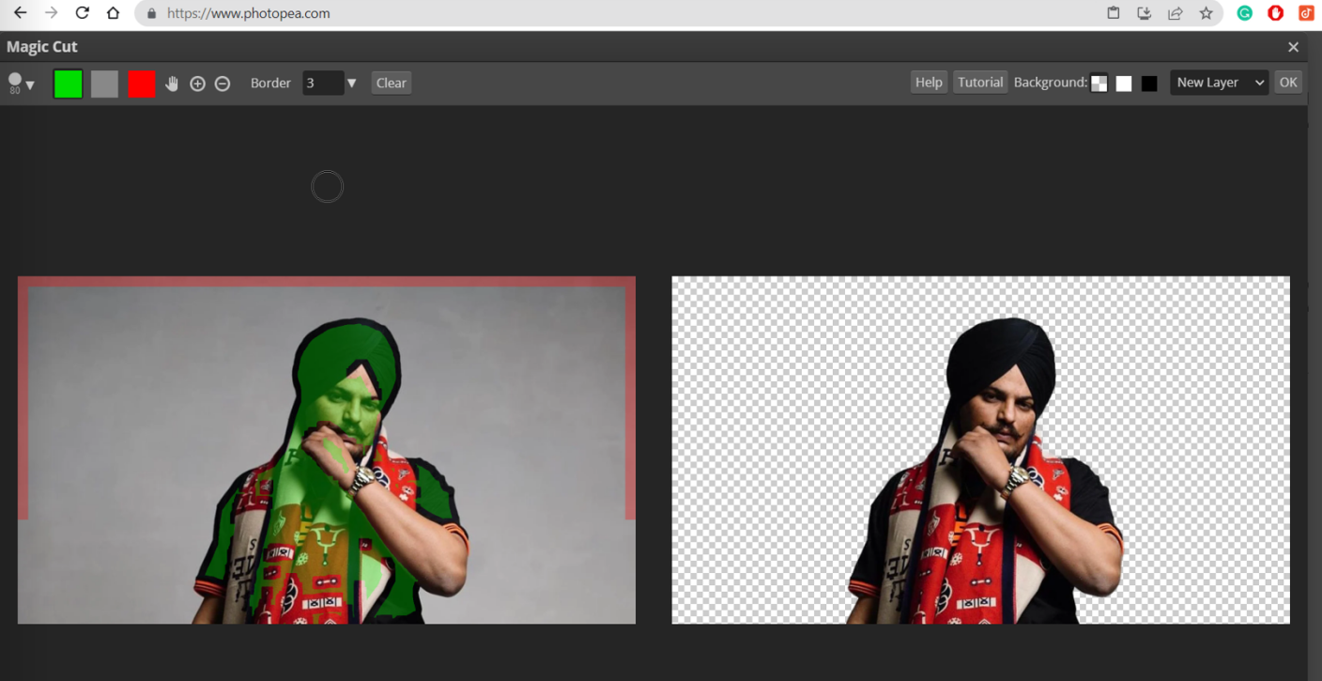

1. **Saturation**

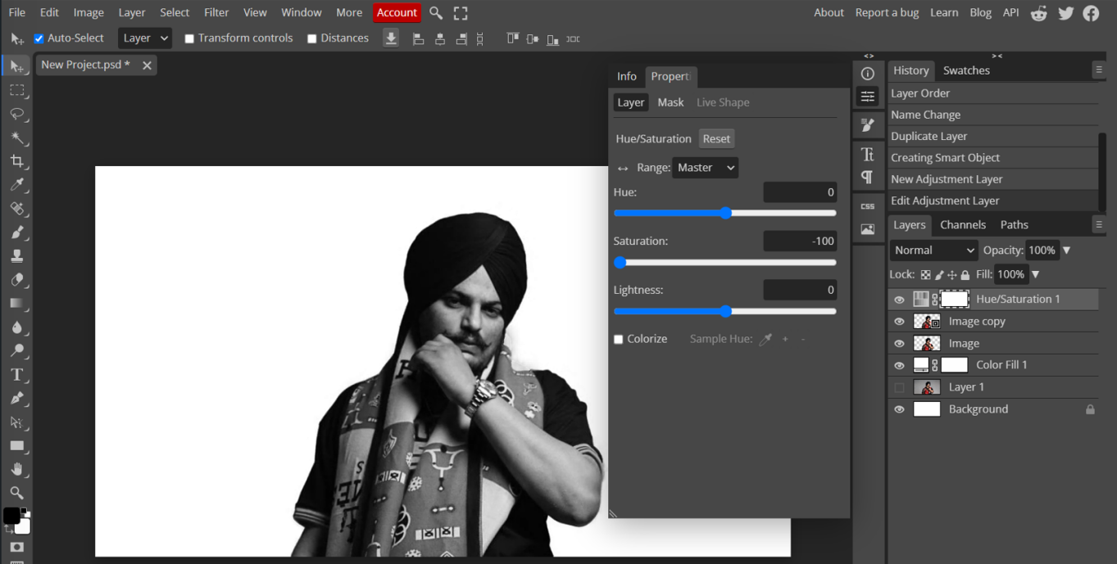

1. **Using Invert tool**

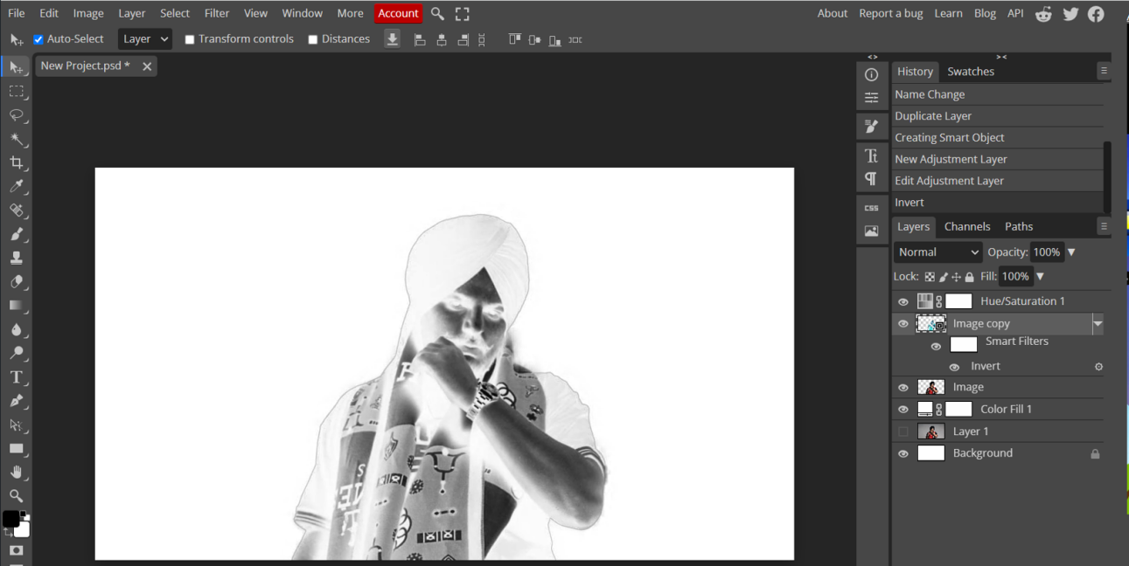

1. **Using Gaussian Blur**

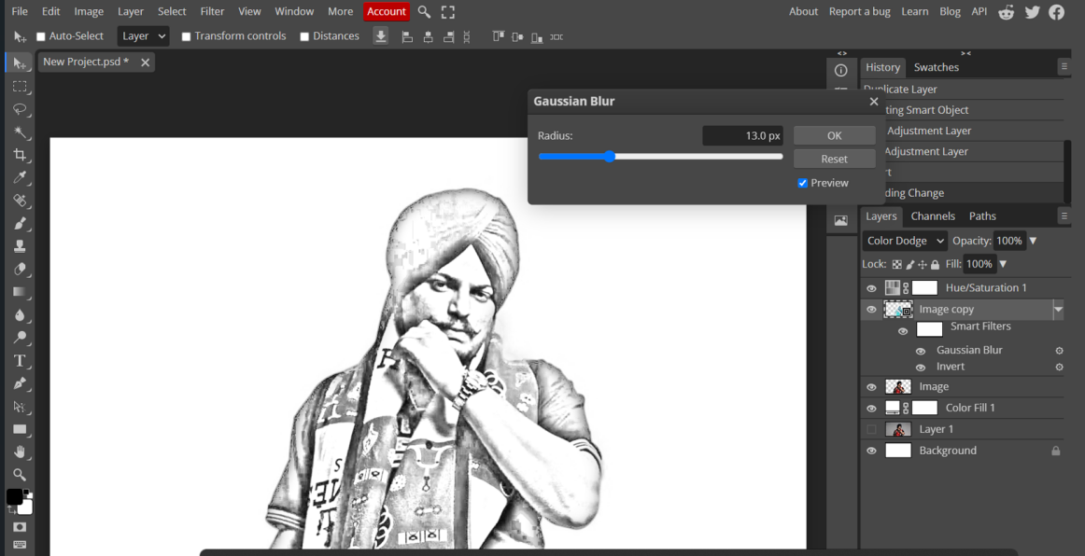

1. **Using Curve tool**

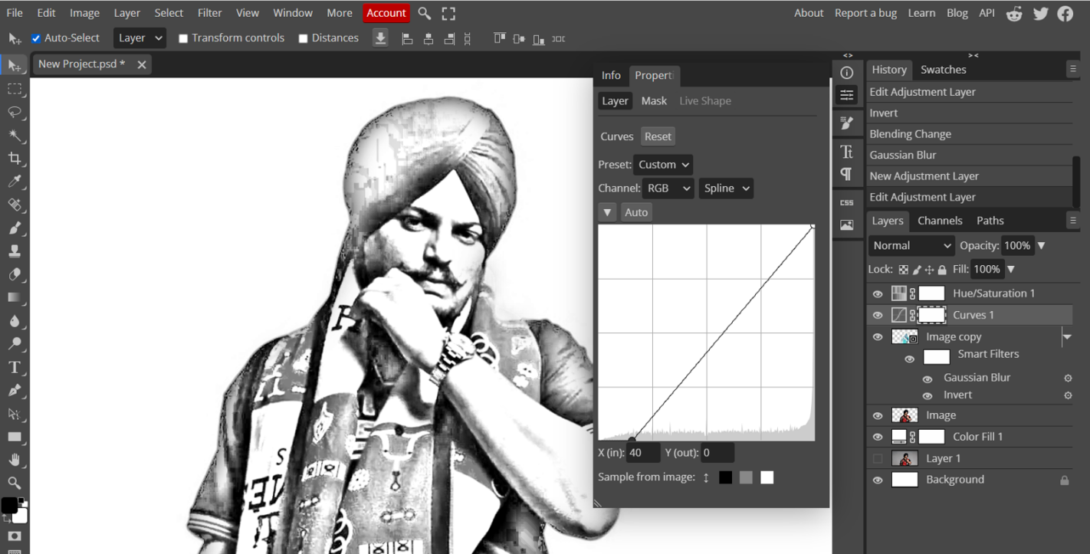

1. **Output**

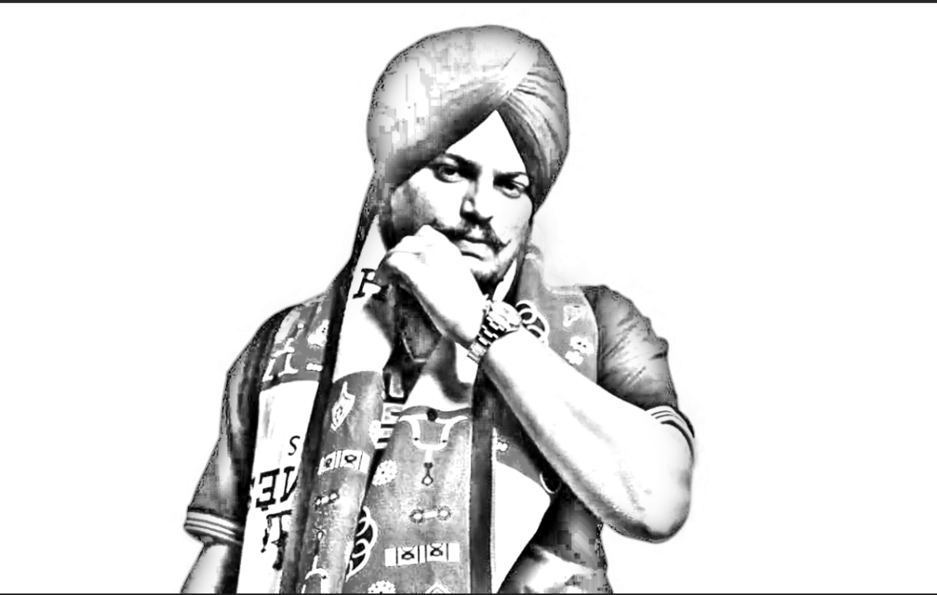

**Learning outcomes (What I have learnt):**

1. I learnt to remove background of a photo in photopea.
2. I learnt how to add saturation and hue to photo in photopea.